10 cm from grille – Mesh comparison

0.05cm HEX Mesh

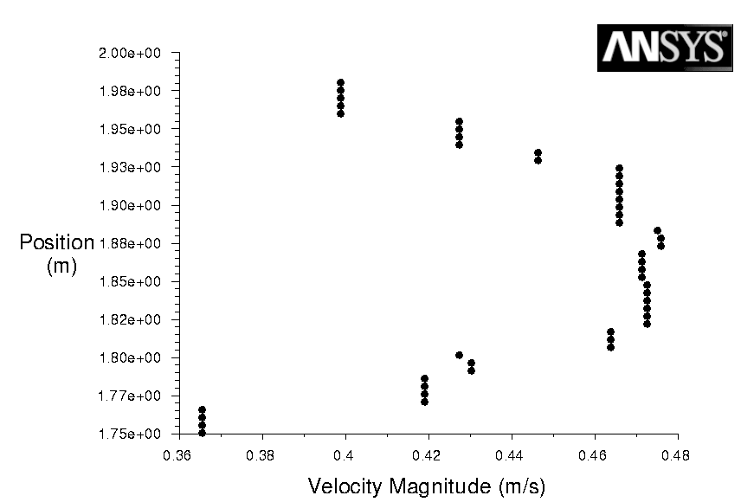

6 Levels of boundary adaption – 0.002cm Hex Mesh

